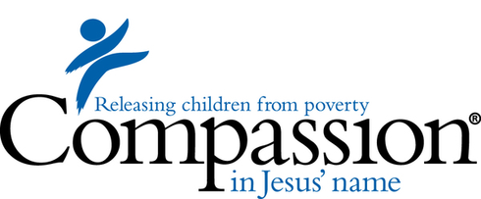
Ethiopia Missions Trip
March 23-31, 2019
City Church will be traveling to Injibara, Ethiopia with our partners, Compassion International. Compassion International operates all over the world as advocates for children in poverty. City Church sponsors over 100 kids in Ethiopia through Compassion International.

What will be doing in Ethiopia?
- Visiting sponsor children’s families and homes
- Sponsor children special outing
- Sharing Jesus with children and their families
- VBS with children from the local Compassion International Projects
- Visiting the mothers/babies ministry at a local church
- Pouring into the leaders at the local church
- Potential for building/facility improvement projects

What does it cost?
Estimated cost: $2900
What’s included in the cost? Air fare, transportation in-country, background check, food & water, lodging, traveler’s insurance, translation costs, and emergency travel fund.

What isn’t included? Passport, vaccinations, meals while in transit, checked bag fees (above airline requirements), events not included on the itinerary, souvenirs.

Additional requirements / costs
- Passport (~$110)
- Visa (~$145)
- World Health Organization (WHO) card with yellow fever vaccination.

What to expect in the process?

- Discipleship
- Study: When Helping Hurts
- Fundraising support
- Spiritual preparation
- Support from your church and leaders

Who can go?

City Church leaders will review each applicant to ensure we have team that is prepared and spiritually fit for this amazing journey. Some of the basic requirements are:

- Completed Growth Track
- Currently Attending a Life Group
- Currently serving on a Go Team
- Water baptized
- Available to attend all team meetings (every other Sunday at 2pm)

What are the next steps?
- Pray – Be obedient to what God places on your heart
- Apply – applications are due by 10/7. You can turn your application in at The Connect Bar.
- Bring a $300 deposit to our first team meeting in October

